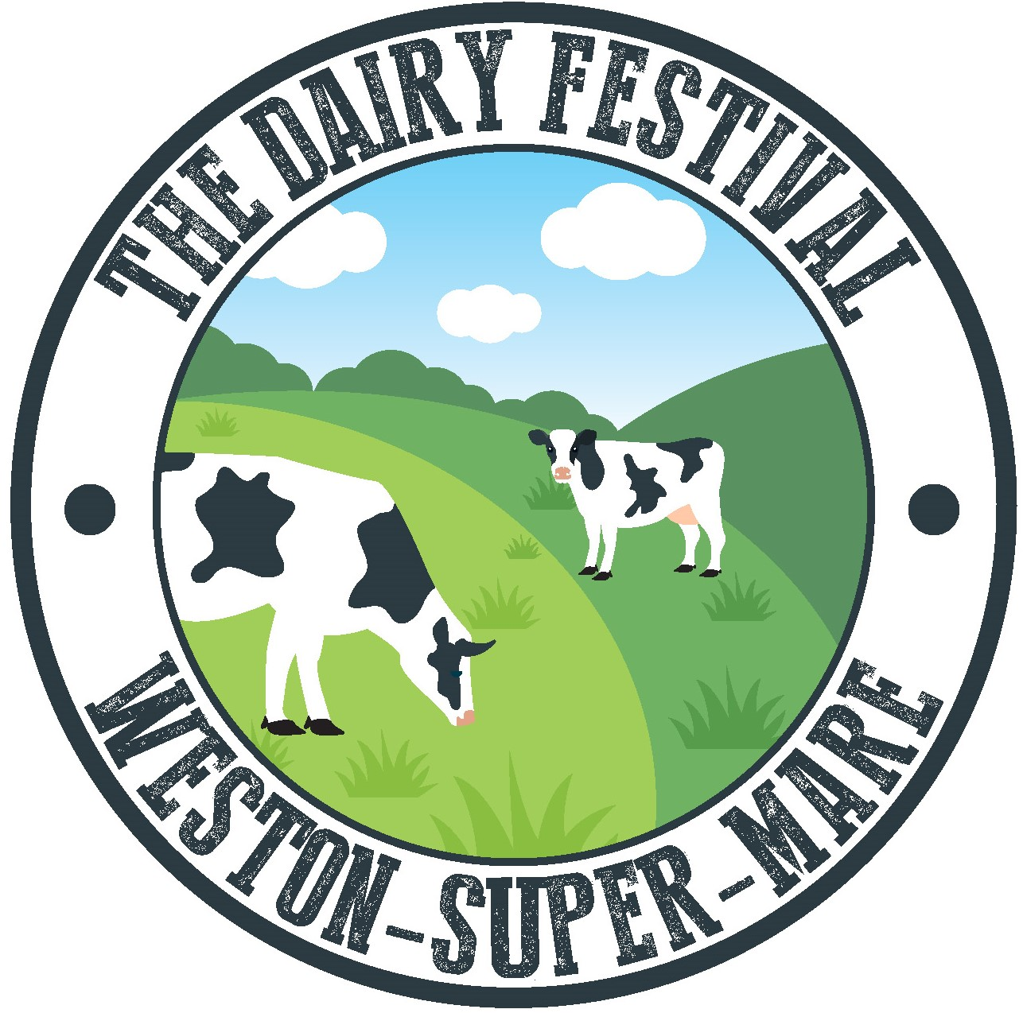
The Dairy Festival
Weston-super-Mare

Concessions Application Form 4th-7th August 2022

Thank you for your interest in being involved in The Dairy Festival. This application form is for food traders and market traders only.

APPLYING
Please complete the form below and return it with the required documents, to
Marketing@puxton.co.uk

Closing date for applications is 14th June 2022 by 5pm.
- Applications must include the following:
  - A copy of your Public Liability Insurance
  - Health and Hygiene Certificate (if a food trader)
  - 2-3 photos of your business or products you’ve made (these will be used to market you on social media channels).
- All applicants will be informed via email if their application has been successful or not by the 19th June 2020.
- All applicants will be sent a confirmation email.
- The booth can be secured with a non-refundable £50 deposit on confirmation.
- Full payment will be due by 26th June 2020 via BACs or Cheque. Please use your business name as the reference and send to

The Dairy Festival  Account No: 81757301  Sort Code: 60-23-32  Reference: Your business name | The Dairy Festival  Cowslip Lane  Hewish  North Someset BS24 6AH

- Once we have received payment, you’ll be sent an email of confirmation and nearer the time, further details of the event.

Event Timings
Thursday 4th August Trader load in 7:30am-9am
Festival opens 10am – 4pm

Friday 5th August Festival opens 10am – 4pm

Saturday 6th August Festival opens 10am – 4pm

Sunday 7th August Festival opens 10am – 4pm
Trader load out 4pm-5pm

FEES
Market traders
Prices are for the full 4 days of The Dairy Festival.

Outside: £120
Please bring your own marques, table etc to a maximum space size of 6m x 6m.

Inside: £150
Each booth will be a fixed size of 3mx3m.
Table is not included in booth hire

Specify your preference for indoor or outdoor space in the Special Requirements box.

A booth can be paid in full now or can be reserved with a non-refundable deposit of £50.
The remaining balance will need to be fully paid by 20^{h} June 2022. Payment must be paid by BACS or cheque.

Food traders
Small caterers: £250
Large catering van (e.g. burger vans): £500 or profit share agreement (please specify your preference in the Special Requirements box).

Passes
Each trader will be given 2 full passes (4 days). Any extra passes will be charged at £2 each.

Your Application

Name:  Address:  Email:  Contact Number: | Business Name:  Nature of Business:  Products available:  Website:

Application Type (please select)

Market trader
Craft [ ]
Food [ ]

Food trader
Small caterer [ ]
Large caterer [ ]

Bio
Please provide a bio below if you would like this to be added to your images when we post online:

Special Requirements.

Vehicle curfew
Market Trader vehicles must be moved to far end car park, which will be signposted. No vehicles after 5pm on site on festival days.

Overnight security is provided on site. The Dairy Festival are not liable for any damages or losses during this time.

Terms and Conditions:

[] I understand the event holder reserves the right to change the venue or dates of the event

[] I understand I must have insurance arrangements to cover public liability and health and hygiene certificates

[] I understand that I must have insurance in place to cover theft, loss and/or damage to possessions or equipment I bring to the event

[] I understand I must not obstruct walkways or encroach into other booths

[] I understand that any damages to the booth or venue must be paid for

[] The festival falls under the jurisdiction of Weston-Super-Mare Council environmental health. I agree to answer any questions or enquiries made by its appointed officers

Date:
Signed:

Printed:

